Navigation Menu

Definition:
# Source: AI Source: Provided by: [Data Path: Persons Table -> ID Column: 1, Name_En Column: Motasem Essam] -> From: [Chatgpt (GPT‑5 Mini)] on [2/12/2026]
A Navigation Menu (also called a Navbar) is a web page component that helps users move between different pages or sections of a website. It is usually placed at the top (in the header) or on the side of a web page.

Simple Definition
# Source: AI Source: Provided by: [Data Path: Persons Table -> ID Column: 1, Name_En Column: Motasem Essam] -> From: [Chatgpt (GPT‑5 Mini)] on [2/12/2026]
Navigation Menu / Navbar = a set of links that guide users through the website.

What a Navigation Menu Usually Includes
# Source: AI Source: Provided by: [Data Path: Persons Table -> ID Column: 1, Name_En Column: Motasem Essam] -> From: [Chatgpt (GPT‑5 Mini)] on [2/12/2026]
- Links to main pages – Home, About, Contact, Services, Blog, etc.
- Dropdown menus (optional) – show sub-pages or categories
- Search bar (optional) – allow quick content search
- Call-to-action buttons (optional) – like “Sign Up” or “Login”
- Responsive design – collapses into a hamburger menu on mobile devices

Purpose of a Navigation Menu
# Source: AI Source: Provided by: [Data Path: Persons Table -> ID Column: 1, Name_En Column: Motasem Essam] -> From: [Chatgpt (GPT‑5 Mini)] on [2/12/2026]
- Help users easily find content
- Improve user experience and accessibility
- Keep the website organized and structured
- Guide users to important actions or pages

Examples
# Source: AI Source: Provided by: [Data Path: Persons Table -> ID Column: 1, Name_En Column: Motasem Essam] -> From: [Chatgpt (GPT‑5 Mini)] on [2/12/2026]
- E-commerce site → links to Home, Shop, Categories, Cart
- Blog → links to Home, Articles, About, Contact
- Corporate site → links to Services, Projects, Careers, Contact

Difference Between Header and Navigation Menu
# Source: AI Source: Provided by: [Data Path: Persons Table -> ID Column: 1, Name_En Column: Motasem Essam] -> From: [Chatgpt (GPT‑5 Mini)] on [2/12/2026]
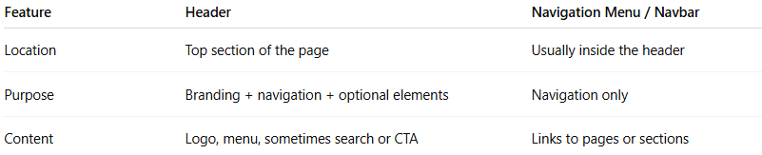
Feature | Header | Navigation Menu / Navbar
Location | Top section of the page | Usually inside the header
Purpose | Branding + navigation + optional elements | Navigation only
Content | Logo, menu, sometimes search or CTA | Links to pages or sections

